Task 1:

**Part A**



**Part B**



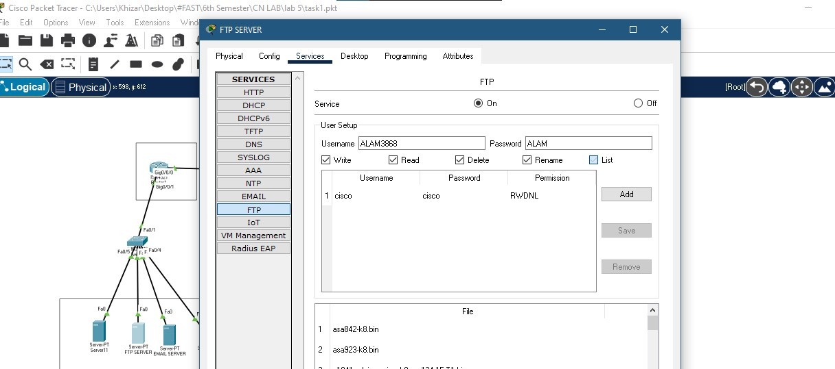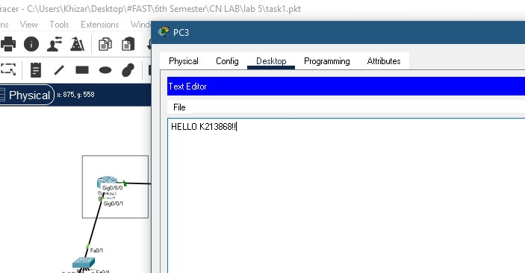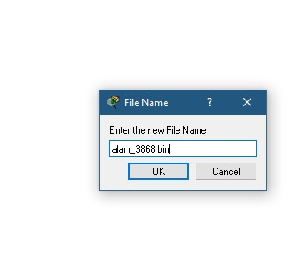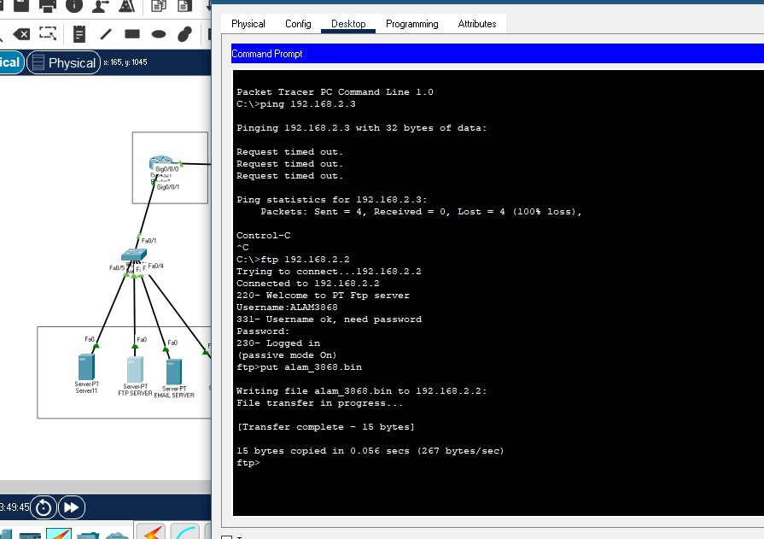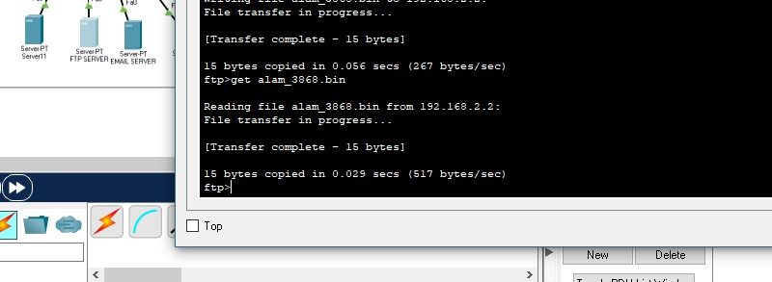



Task 2:

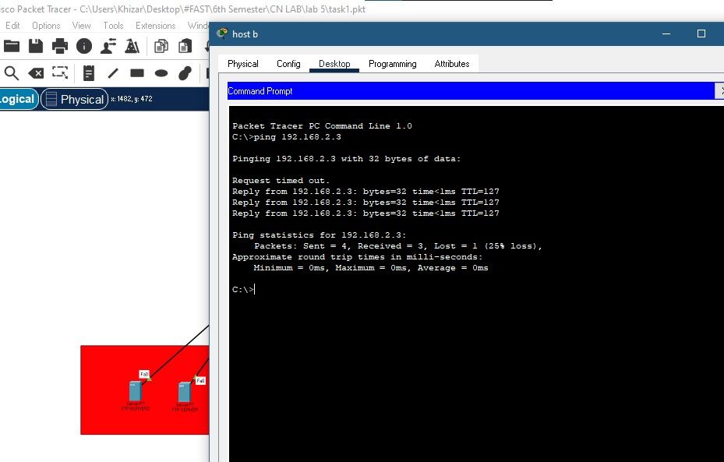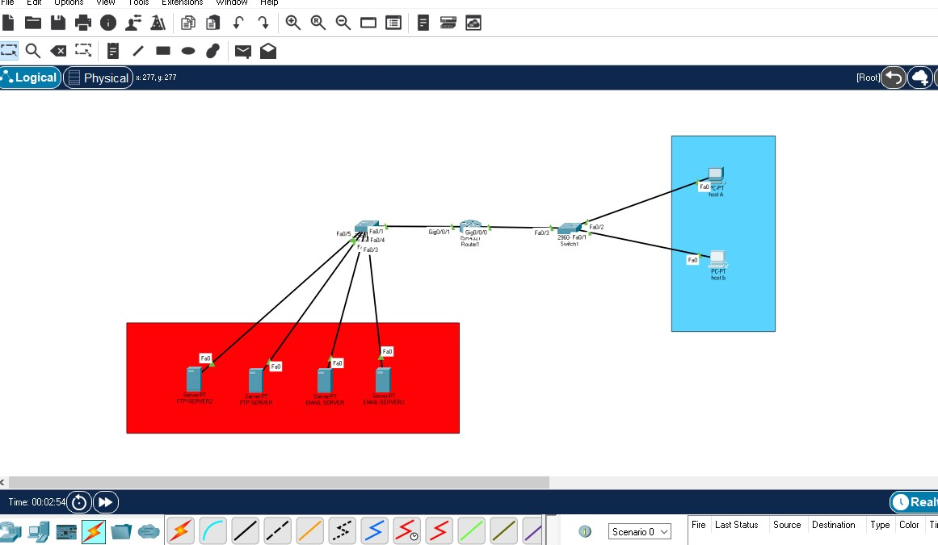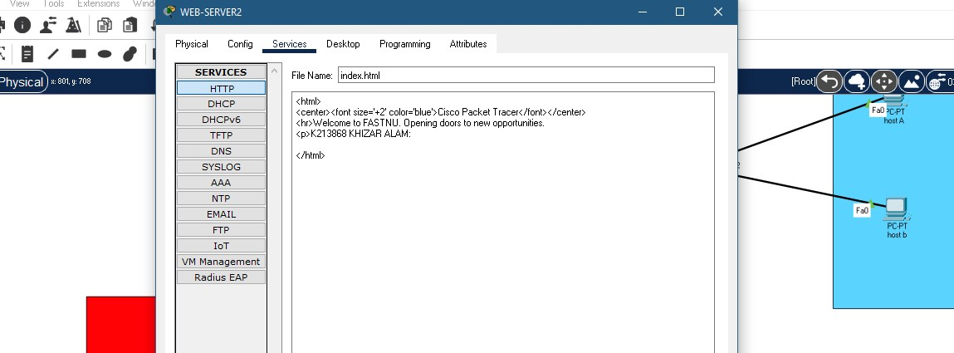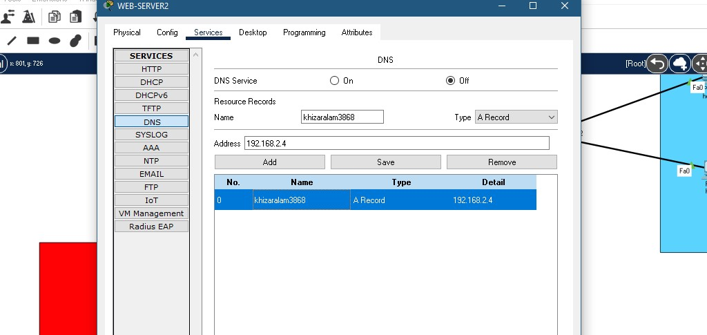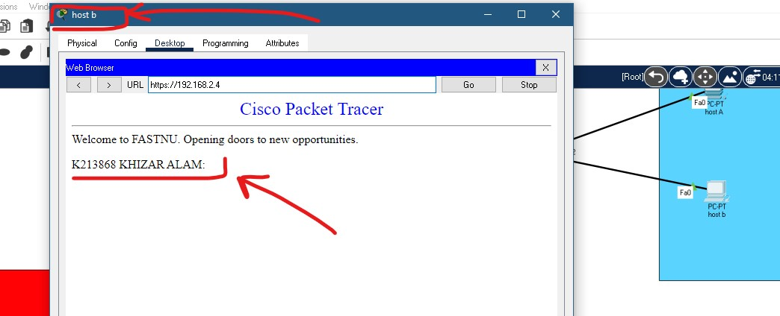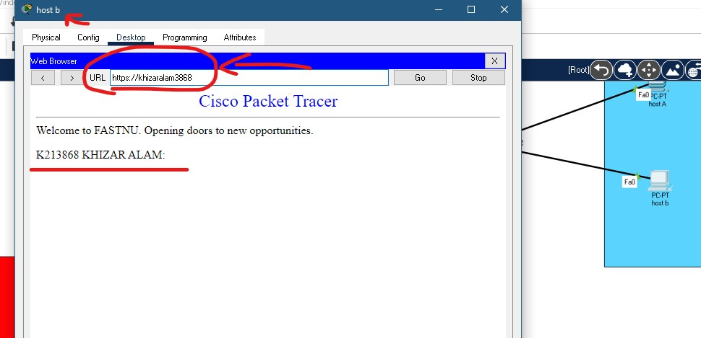

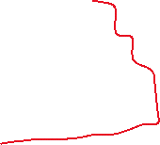

**Part b:**

**Part c:**

**Part d:**

